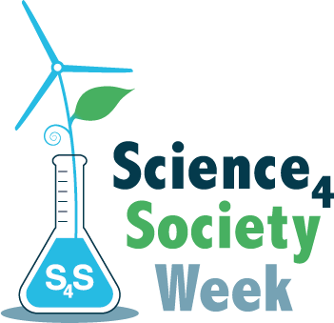
‘Globally Responsible Careers’

S4S Week 2019 competition

In collaboration with The Association for Science Education
What job do you want to do? What are your career aspirations?
How might this job impact on the local/national/global environment? e.g. air/land/water pollution, biodiversity, flooding, climate etc.
What are the scientific issues involved?
How could you help to make this job more globally responsible?

Your entry must answer these questions and could be in any form, including:
- Poster
- Film (5 minutes max)
- Essay (500 words max)
- Presentation (5 slides max)
But could include other formats – just contact us to discuss - janm@sgr.org.uk or call 01524 812073
The important thing is that your medium captures your answers – and so can be an inspiration to others.

The winning entry will
- Receive a certificate
- Be published on the ASE website, S4S website and in the Education In Science journal

For ideas about ‘Am I a Good Scientist?’ see the resources on www.s4s.org.uk

All entrants must be within the age categories below:
7-11, 12-14, 15-18
We welcome entries from schools, science clubs, youth groups and other organisations
- Entries must be in a form that can be attached to an email
- Work must be original and created by the student(s)
All entries must include the following information
  - entrant name and age
  - age category
  - school/club/youth group name and address

Submit your entry to info@s4s.org.uk by midday Friday 1st March 2019

