Mark scheme Where does food come from? Initial ideas worksheet. Guidance for teachers.
- Where do animals get their food?  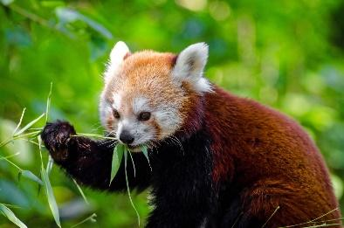  The primary purpose of this task is to shine light on student’s ideas allowing the teacher to clearly see misunderstandings. We are not looking so much for correct answers at this point but rather to help students build a coherent, deeper understanding of the process and role of photosynthesis.  Students will have no difficulty knowing where animals get food from, or relating this to mass. | - Where do plants get their food?  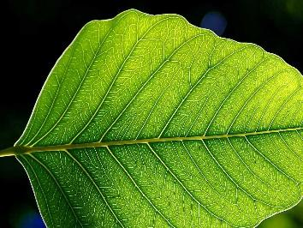  Here we are probing for understanding, not simply the word “photosynthesis”  The question below helps tease this out: do students really get that most of the mass of a plant comes from CO₂ ? very little from the soil? Do they demonstrate understanding that photosynthesis is not only about transforming energy but also about matter, the source of organic material which forms the basis of living things? Are they clear that light is the source of energy not mass?  Student’s answers may also reveal a misconception that animals respire and plants photosynthesis, seeing these as equivalent processes, rather than seeing the equivalence of eating and photosynthesis.
Where does the mass of an animal come from?  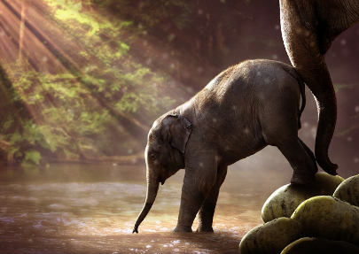  The mass of the atoms consumed minus the mass of the atoms released following respiration (do students appreciate that respiration involves a loss of mass when CO₂ and H₂O are lost from the organism?)and any products which leave the animals body ( babies, milk, urine, faeces, sweat etc) | - Where does the mass of a plant come from?  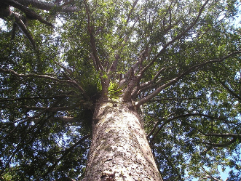  Mass of the atoms fixed in photosynthesis plus minerals absorbed from soil, minus mass of atoms lost following respiration and any products which leave the plant eg leaf fall, seeds, pollen, nectar.

